RECOGNITION OF HUMAN ACTION UNDER VIEW CHANGE

Under the guidance of

Dr.Shiloah Elizebeth

Prepared By:

Group Name : msmgp

Murugappan N

Maaniccka Sentil Ma P

Mohamed Shamsudeen G

Screenshot 1:

Initial Diagram

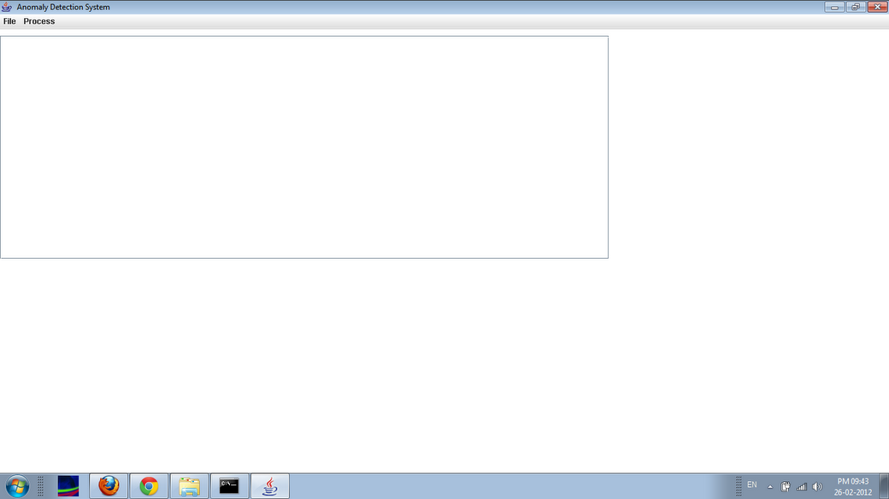

Screenshot 2:

"File" Menu

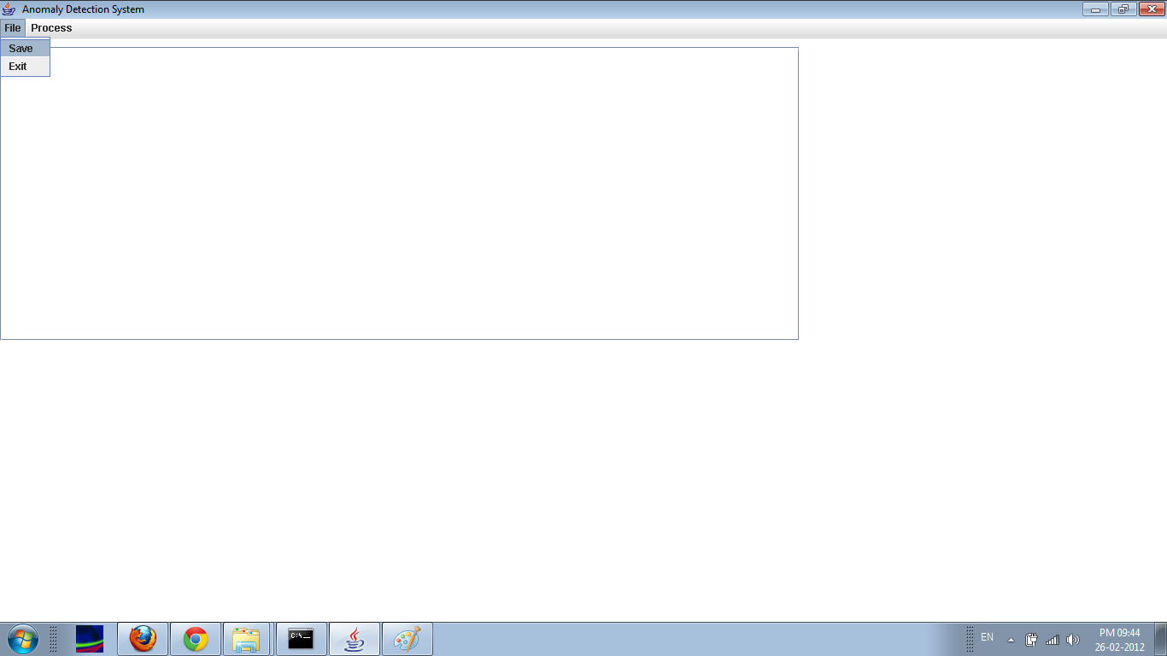

Screenshot 3:

"Process" Menu

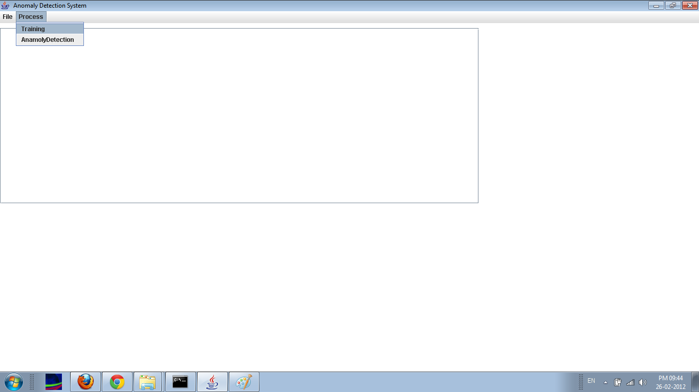

Screenshot 4:

Training View Window

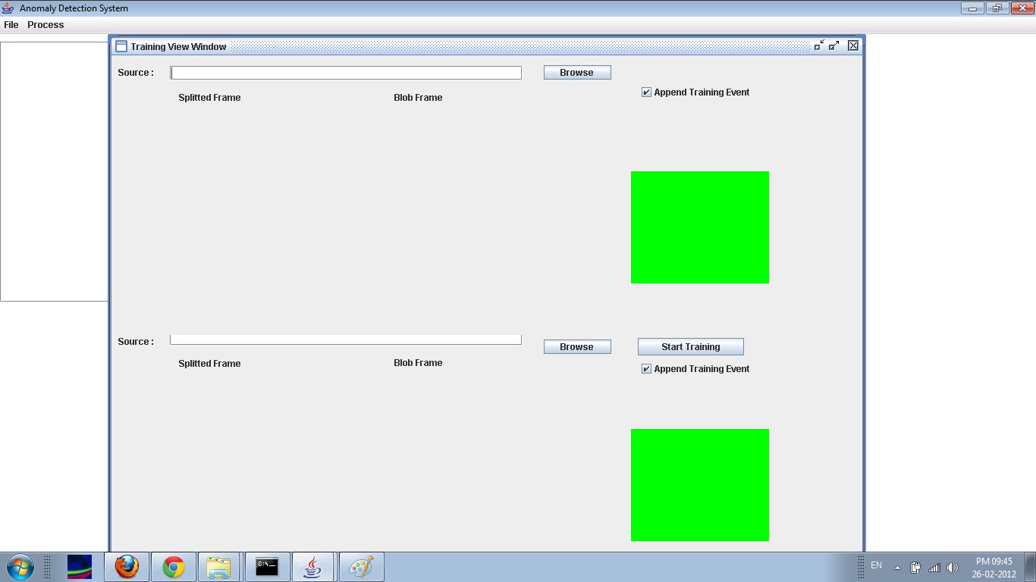

Screenshot 5:

"Browse" Menu

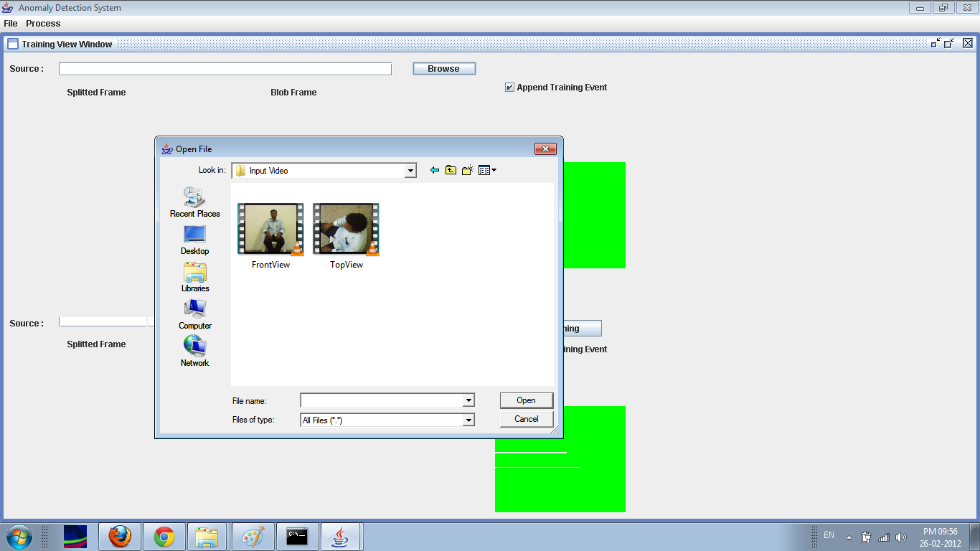

Screenshot 6:

"Incorrect" Filename

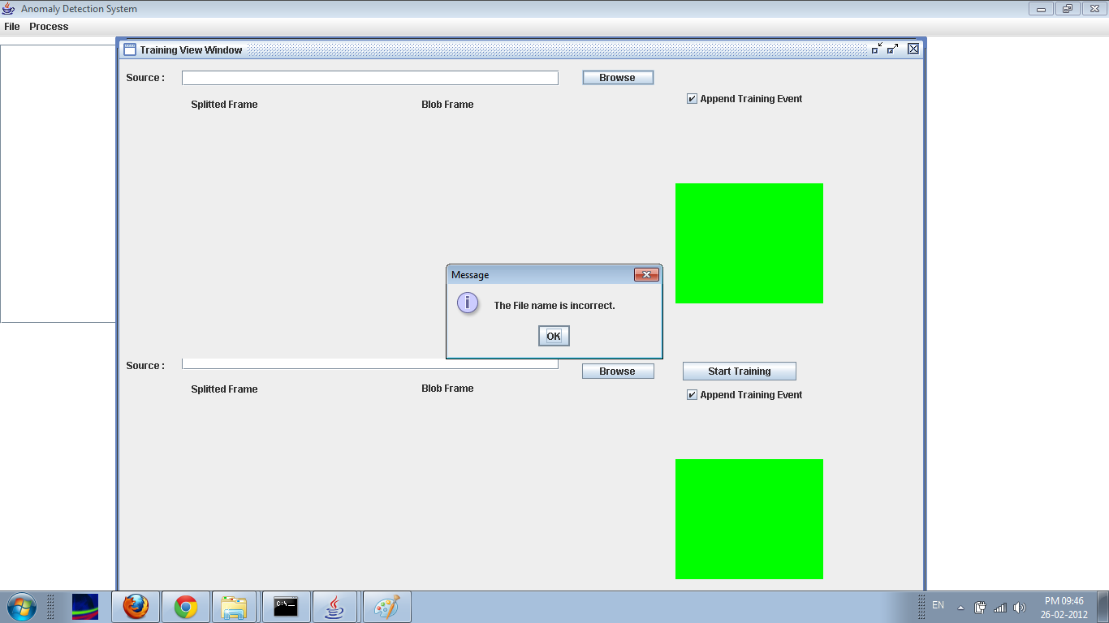

Screenshot 7:

"Proper Front View" Filename

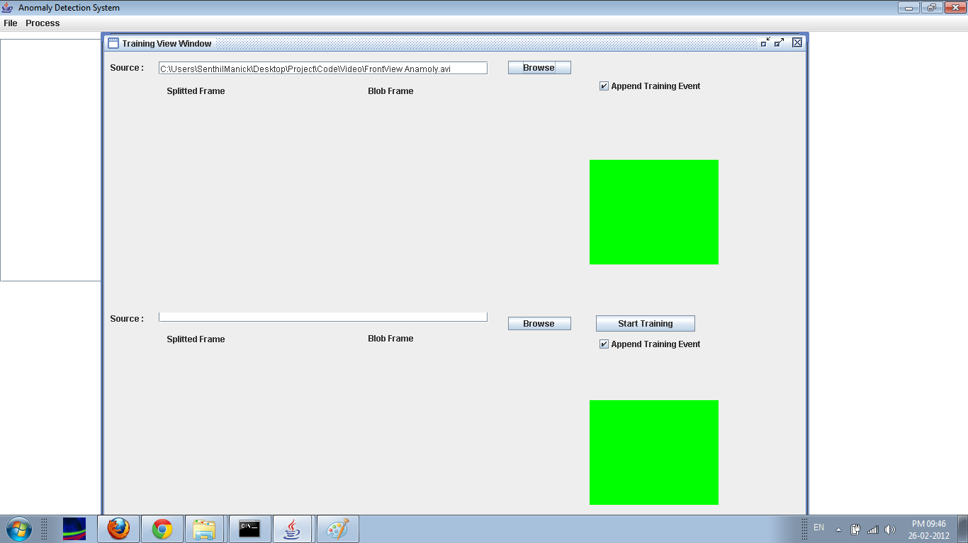

Screenshot 8:

"Proper Top View" Filename

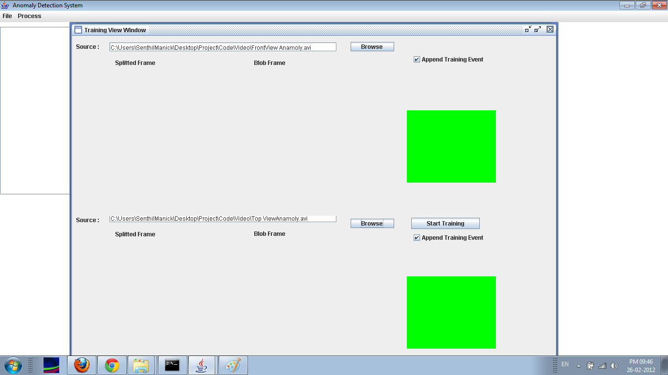

Screenshot 9:

Frame Extraction 1

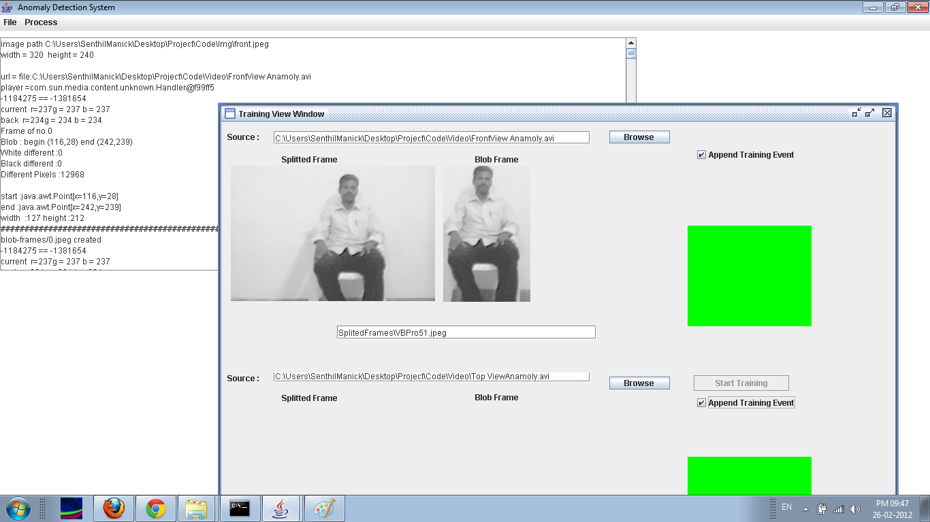

Screenshot 10:

Frame Extraction 2

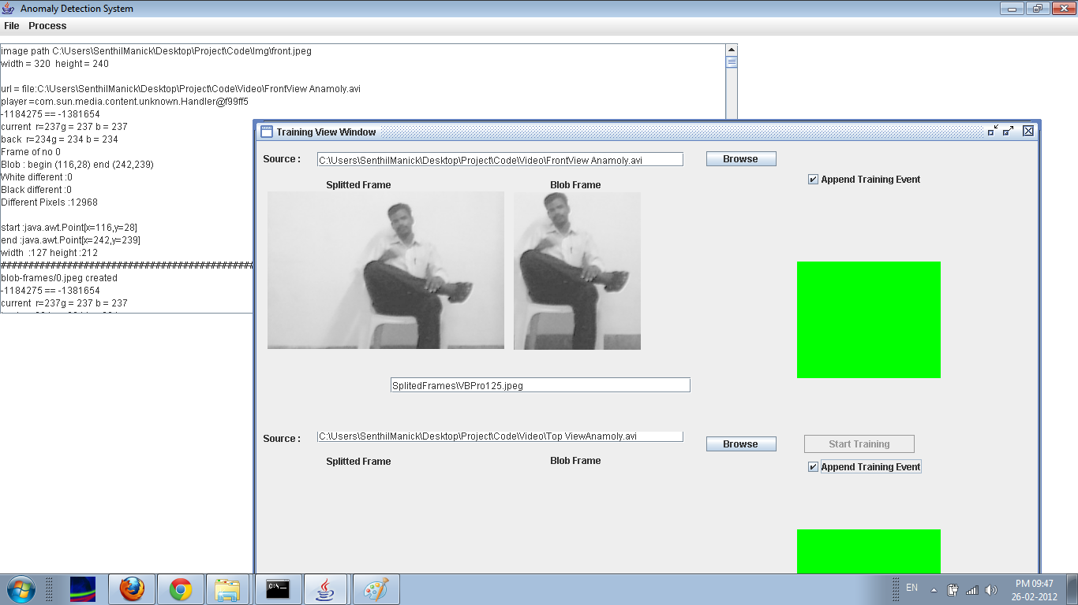

Screenshot 11:

Frame Extraction 3

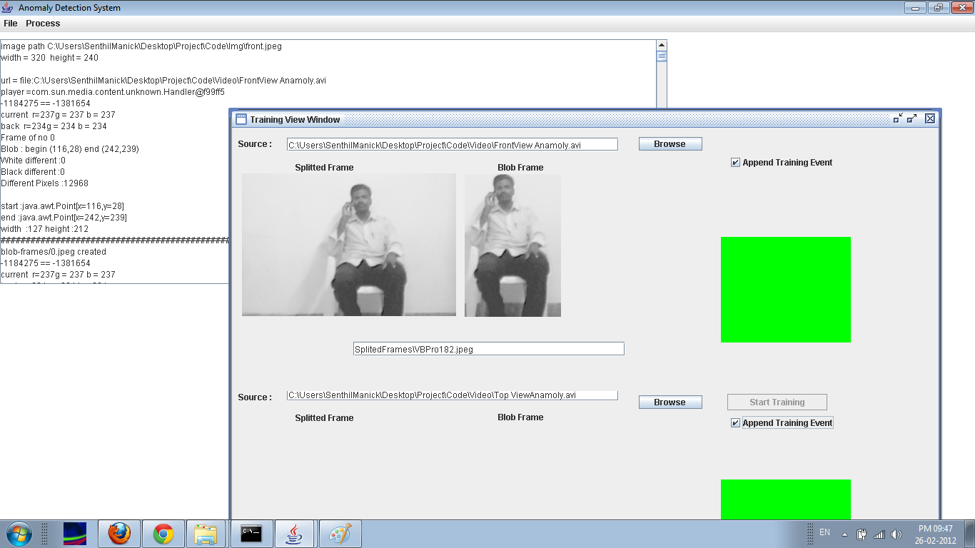

Screenshot 12:

Training Phase Finished

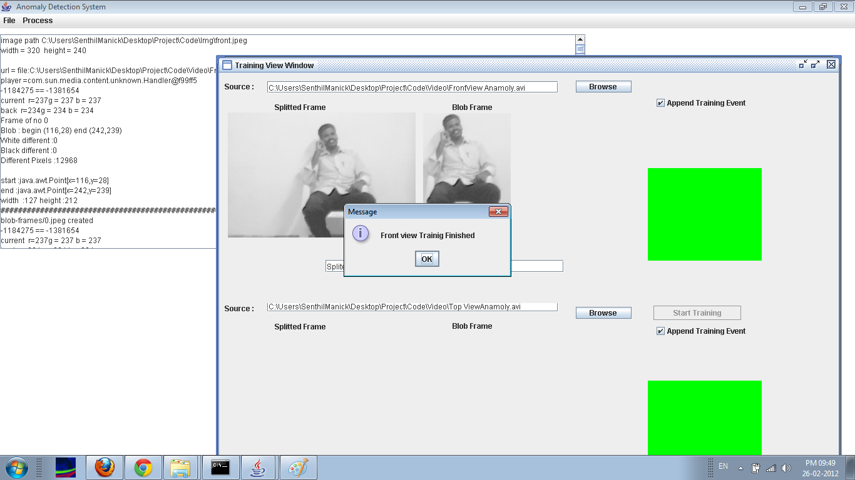

Screenshot 13:

Gantt Chart

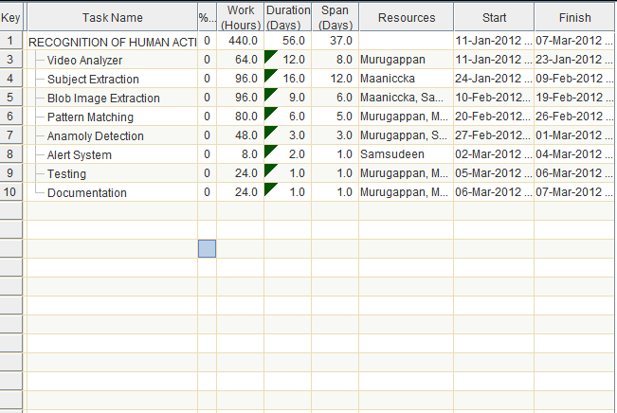

Screenshot 14:

Gantt Chart

